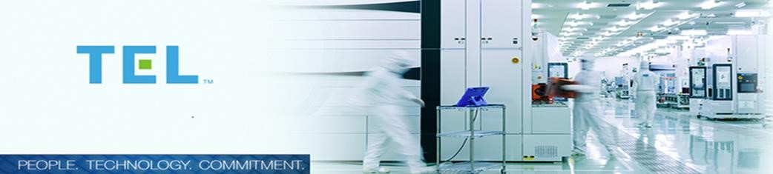
FSE Engineer
Established in 1963, Tokyo Electron (TEL) is a leading global company of innovative semiconductor and flat panel display production equipment. We are committed to empowering the newest advancements in technology and to the progress of our future equipment, providing innovative tools and always supporting our global customers as a Trusted Partner.

In Europe, since 1994 we have expanded operations and we now operate in 9 Countries with more than 500 employees. Our business is focused on ‘Sales & Service’ supporting and developing customers’ needs across Europe. Even though we are a big team, fundamental is always our constant relationship with our Head Quarter in Japan and with our other Subsidiaries.

Above all, our employees remain the essential element for our continued growth and success.

About the role:
New positions have become available for Engineers supporting Tokyo Electrons operations in Kildare. The positions will provide high quality service and installation support across numerous customers within the region. As the customer based is diverse, applicants should be customer focused and comfortable to work within a changing environment. The positions require a high level of flexibility, and may involve international travel. Successful candidates should ideally have gained experience on either Clean Track or Furnace tools, but will receive full training as required to fulfil the role.

General requirements & expectations

All employees are expected to demonstrate flexibility and adaptability to Tokyo Electron Europe (Irish Branch) business requirements and carry out other work that falls within the scope of their abilities as requested by TEE Limited. This is likely to involve visits to, or periods working at, any TEE office.

A positive team-working approach and adherence to Safety Policies and Procedures is essential.
A professional telephone manner, good level of interpersonal and self-presentation skills are pre-requisites.

In support of our mission statement to deliver QUALITY, CUSTOMER SATISFACTION AND STAFF SATISFACTION, employees will be expected to support colleagues and management as required and to contribute ideas and suggestions in our search for CONTINUOUS IMPROVEMENT.

In addition to the above the other requirements of the role are:
• Taking personal ownership to maintain our incident and injury free environment.
• Participating as part of a shift team to deliver world class performance on critical success indicators (Safety, Quality, Output & Equipment performance) in a highly automated wafer fabrication facility.
• Scheduling & completing preventative maintenance tasks on advanced semiconductor processing equipment.
• Using problem solving skills to troubleshoot & resolve unscheduled equipment & inline process issues.
• Applying statistical process control techniques to monitor, maintain & improve process & equipment performance.
• Commitment to travel on assignment for varying duration depending on business need.
• This role is based on a monthly rotating shift pattern.

Qualifications:
• Strong analytical & problem-solving skills.
• Pro-active with an ability to work with minimal supervision.
• Excellent written and verbal communication skills.
• Ability to work as part of a high performing team.
• High level of attention to detail with demonstrated capability of following procedures closely.
• Good planning & organisation skills.

Required Qualifications:
- an ordinary degree in electrical engineering, electronic engineering, automation engineering or equivalent with 0-3 or more years of equipment experience or
- an trade apprenticeship and qualification in electrical engineering or equivalent with 0-3 years of equipment experience

Advantageous Supplementary Skills

• Vacuum furnace experience
• Working in a cleanroom environment
• Working knowledge of superconducting & large permanent magnets
• Working handling cryogenic liquids
• Experience of new equipment commissioning and customer sign-off processes, or plant commissioning

Tokyo Electron offers an excellent, comprehensive benefits and compensation package. For immediate consideration please apply via tee.hr.ireland@europe.tel.com
For more information about TEL please click here: www.tel.com

